**第4课时 挑战思维——动词现在分词与时间的互动解码**

**————————————拓展资源—————————————**

**读故事 学英语**

**文章导读：**今天推荐给同学们的拓展资源是由外语教学与研究出版社和牛津大学出版社联合出版的英语分级阅读“书虫”系列中的《摩托车女孩》。希望同学们通过大量广泛的阅读，提高英语的综合运用能力。

故事讲述的是肯尼正在乘公共汽车横穿美国去往旧金山的旅途中。这是一段漫长的旅程，所以有时他会停下来，在汽车旅馆住上一夜。一天晚上，他住在加利福尼亚一个小镇的汽车旅馆里。他从房间下楼去吃东西时，看见了一个女孩—骑着摩托车，一头金色长发。他觉得自己认识她—她是名人吗？然后，第二天早上，他从新闻里看到洛杉矶的一起超市劫案。

**Thinking and Speaking**

*Do you think the story ______? A. funny B. exciting C. frightened D.sad*

1.Is there a motel？

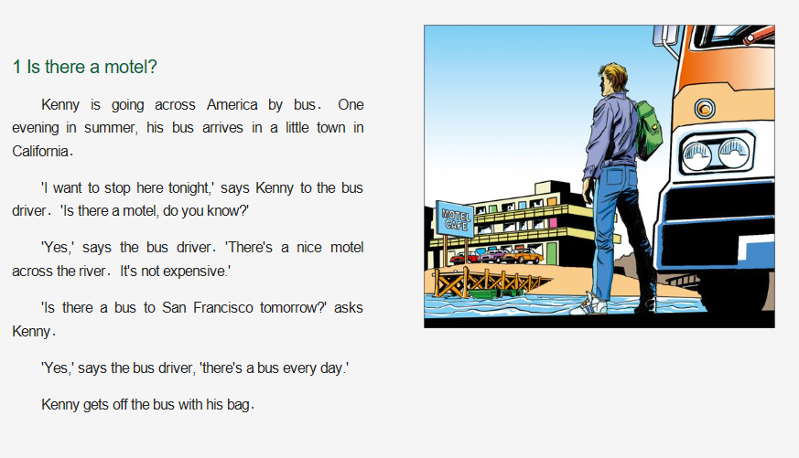Kenny is going across America by bus．One evening in summer，his bus arrives in a little town in California．

　'I want to stop here tonight，' says Kenny to the bus driver．'Is there a motel，do you know？'

　　'Yes，' says the bus driver．'There's a nice motel across the river．It's not expensive．'

　　'Is there a bus to San Francisco tomorrow？' asks Kenny．

　　'Yes，' says the bus driver，'there's a bus every day．'

Kenny gets off the bus with his bag．

2. Give me the money!

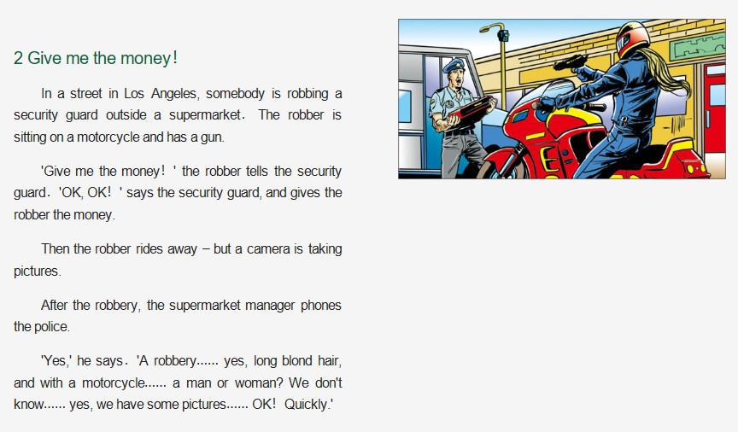　　In a street in Los Angeles，somebody is robbing a security guard outside a supermarket．The robber is sitting on a motorcycle and has a gun．

　　'Give me the money！' the robber tells the security guard．'OK，OK！' says the security guard，and gives the robber the money．

　　Then the robber rides away – but a camera is taking pictures．

　　After the robbery，the supermarket manager phones the police．

'Yes，' he says．'A robbery．．．yes，long blond hair，and with a motorcycle．．．a man or woman？We don't know．．．yes，we have some pictures．．．OK！Quickly．'

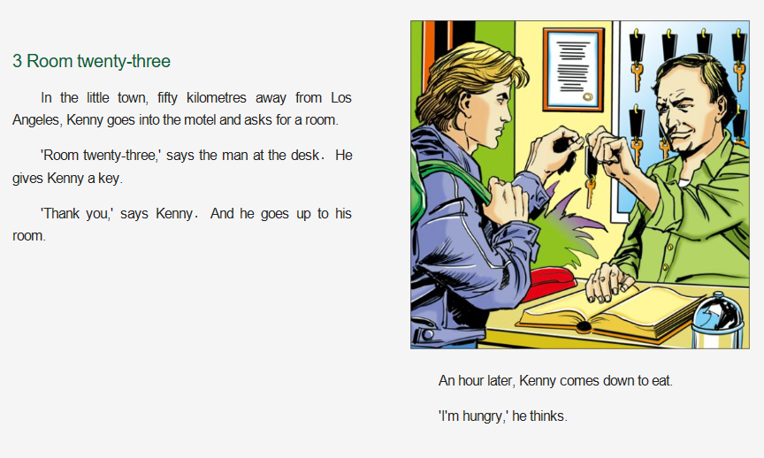3. Room twenty-three

　　In the little town，fifty kilometres away from Los Angeles，Kenny goes into the motel and asks for a room．

　　'Room twenty-three，' says the man at the desk．He gives Kenny a key．

'Thank you，' says Kenny．And he goes up to his room．

**Word Bank**

security n. 保护措施； 保安部门

robber n. 强盗，抢窃犯