**第3课时 挑战思维 --动词过去式与时间的互动解码**

**————————————拓展资源—————————————**

**看新闻 学英语**

**新闻导读：**2020年1月27日，就在我们全国都在斗争新型肺炎的时候，在遥远的美利坚却发生了一起让世界悲伤的事情。美国体育媒体ESPN、新闻媒体ABC及娱乐新闻媒体TMZ等多家媒体报道，NBA球星科比·布莱恩特在当地时间周日26号，于加利福尼亚州洛杉矶县卡拉巴萨斯的一场直升机坠机事故中身亡。

**Heroes come and go, but legends are forever**

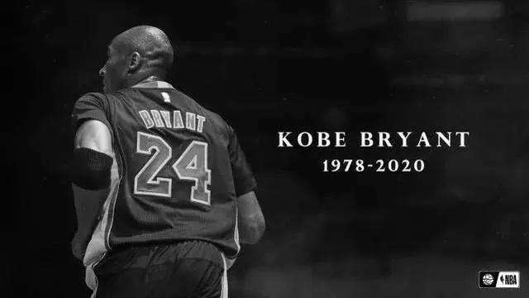Basketball fans around the world are mourning the death of American superstar Kobe Bryant.

Bryant was killed in a helicopter crash Sunday in California, along with his 13-year-old daughter Gianna and seven other people. He was 41 years old.SS!59dxgZLdC

Bryant was an 18-time All-Star player. He won five NBA championships and two Olympic gold medals. He was widely considered one of the greatest basketball players of his generation during his 20-year career with the Los Angeles Lakers.

The helicopter carrying Bryant and the others crashed into a hilly area in foggy conditions outside Los Angeles. Bryant lived south of Los Angeles and often used helicopters to travel around the area to save time and avoid Southern California traffic.

The cause of the crash is under investigation. It took place about 32 kilometers from Bryant's Mamba Sports Academy, a basketball training center in Newbury Park, California. Bryant was on his way to attend a youth basketball competition on Sunday with his daughter. Bryant and his wife, Vanessa, had four daughters.

When he retired from the NBA in 2016, Bryant was the third-leading scorer in NBA history with 33,643 points. He is widely expected to be elected to the Naismith Memorial Basketball Hall of Fame this year.

The basketball world and the Los Angeles community reacted to Bryant's death with an outpouring of sadness, disbelief and support.

In a statement, NBA Commissioner Adam Silver said Bryant was one of the greatest stars in the game. But he added, He will be remembered most for inspiring people around the world to pick up a basketball and compete to the very best of their ability.

On Twitter, U.S. President Donald Trump noted the terrible news. He called Bryant one of the truly great basketball players of all time who was just getting started in life.

**Word Bank**

championship n. 锦标赛；冠军称号；冠军的地位

generation n. 一代人；时代

crash n. 碰撞

**Thinking and Speaking**

*Is Kobe Bryant your hero?*

*What do you know about Kobe Bryant?*

注：文章选自《可可英语》网站

文章及音频链接：

http://www.kekenet.com/broadcast/202001/604104.shtml