**第1课时 挑战思维 --动词原型、三单与时间的互动解码**

**————————————拓展资源—————————————**

**看电影 学英语**

**电影简介：**《冰雪奇缘》（Frozen）是2013年[迪士尼](https://baike.baidu.com/item/%E8%BF%AA%E5%A3%AB%E5%B0%BC/1573169)出品3D的动画电影，由[克里斯·巴克](https://baike.baidu.com/item/%E5%85%8B%E9%87%8C%E6%96%AF%C2%B7%E5%B7%B4%E5%85%8B/20295546)、[珍妮弗·李](https://baike.baidu.com/item/%E7%8F%8D%E5%A6%AE%E5%BC%97%C2%B7%E6%9D%8E/24182785)执导。 该片改编自[安徒生](https://baike.baidu.com/item/%E5%AE%89%E5%BE%92%E7%94%9F)童话《[白雪皇后](https://baike.baidu.com/item/%E7%99%BD%E9%9B%AA%E7%9A%87%E5%90%8E/68913)》，讲述小国阿伦黛尔因一个魔咒永远地被冰天雪地覆盖，为了寻回夏天，安娜公主和山民克里斯托夫以及他的驯鹿搭档组队出发，展开一段拯救王国的历险。

电影中有很多经典台词，让大家边看电影边学英语。

1. You are not afraid of her?

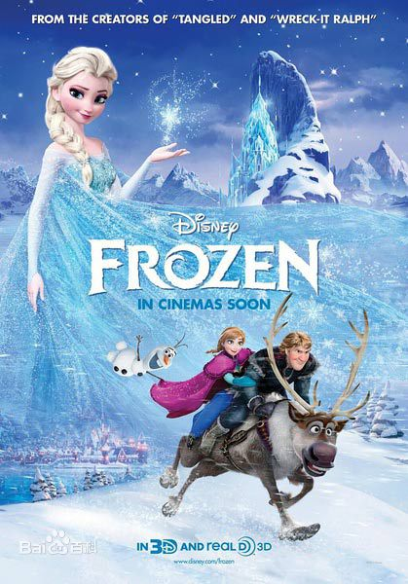你不怕她吗?

2. She is my sister, she would never hurt me.

她是我姐姐，她绝对不会伤害我。

3. Yes, I think she is the most kind-hearted people, isn't it?

没错，我觉得她是最善良的人，不是吗?

4. You can be really terror.

你可真是恐怖。

5. Hello, my name is located.

大家好，我叫雪宝。

6. You are Elsa out of the heap?

你是爱莎堆出来的吗?

7. We need Elsa to take over the summer.

我们需要爱莎把夏天带过来。

8. Don't you understand? I can't make it.

你不明白吗?我做不到。

9. That is not a snow storm, it is my sister!

那不是暴风雪，那是我姐姐!

10. Some people worthy of me melt, but it seems that now is not the time.

有些人值得我融化，但好像现在不是时候。

**Word Bank**

terror n.惊恐; 恐惧;

melt v.(使) 熔化，融化

be afraid of 害怕，担忧

**Thinking and Speaking**

*Which role is your favorite in this film?*

链接:腾讯视频 *https://v.qq.com/x/cover/4yudfz3zbr4upj6/o0015om7f05.html*