**第一周第五课时《在失物招领处如何表达》学习任务单**

任务一、请同学们把下列图片和单词连线。

IMG_256 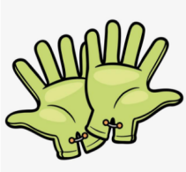   

a b c d e

1. tape 2. crayons 3. gloves 4. watch 5. wallet

任务二、请同学们把下列图片和单词连线。

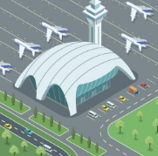  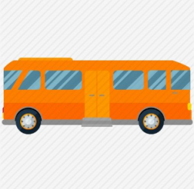 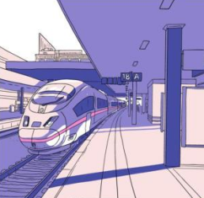

a b c d

1. taxi 2. bus 3. train station 4. airport

任务三、连词成句。

1. are, yours, gloves, these  
   \_\_\_\_\_\_\_\_\_\_\_\_\_\_\_\_\_\_\_\_\_\_\_\_\_\_\_\_\_\_\_\_\_\_\_\_\_\_\_\_\_\_\_\_\_\_\_\_\_\_\_\_\_\_\_\_\_.  
   2. is, his, looking for, Tony, crayons

\_\_\_\_\_\_\_\_\_\_\_\_\_\_\_\_\_\_\_\_\_\_\_\_\_\_\_\_\_\_\_\_\_\_\_\_\_\_\_\_\_\_\_\_\_\_\_\_\_\_\_\_\_\_\_\_\_.  
3. can, you, find, your, at, things, the lost and found office

\_\_\_\_\_\_\_\_\_\_\_\_\_\_\_\_\_\_\_\_\_\_\_\_\_\_\_\_\_\_\_\_\_\_\_\_\_\_\_\_\_\_\_\_\_\_\_\_\_\_\_\_\_\_\_\_\_.  
4. is, where, the lost and found office  
\_\_\_\_\_\_\_\_\_\_\_\_\_\_\_\_\_\_\_\_\_\_\_\_\_\_\_\_\_\_\_\_\_\_\_\_\_\_\_\_\_\_\_\_\_\_\_\_\_\_\_\_\_\_\_\_\_?  
5. mine, this, book, is not  
\_\_\_\_\_\_\_\_\_\_\_\_\_\_\_\_\_\_\_\_\_\_\_\_\_\_\_\_\_\_\_\_\_\_\_\_\_\_\_\_\_\_\_\_\_\_\_\_\_\_\_\_\_\_\_\_\_.