**第一周第三课时《用英语讲时事》学习任务单**

一、热身活动。请你根据图片及提示信息，写出图片上的人物正在做什么。

|  |  |  |
| --- | --- | --- |
| IMG_256 |  | **?** |
| 1.--What is the boy doing at the  moment?  --He is\_\_\_\_\_\_\_(play) football. | 2.--Look! What are the children doing?  --They\_\_\_\_\_\_(swim) . | 3.--What are you doing now?  --I \_\_\_\_\_\_\_. |

1. 请你观看微课《用英语讲时事》，并完成以下任务。
2. 通过微课复习后，请你总结一下我们在什么时候会使用“现在进行时”，并写出该时态的句型结构及提示词。

\_\_\_\_\_\_\_\_\_\_\_\_\_\_\_\_\_\_\_\_\_\_\_\_\_\_\_\_\_\_\_\_\_\_\_\_\_\_\_\_\_\_\_\_\_\_\_\_\_\_\_\_\_\_\_\_\_\_\_\_\_\_\_\_\_\_\_\_\_\_\_\_\_\_\_\_

\_\_\_\_\_\_\_\_\_\_\_\_\_\_\_\_\_\_\_\_\_\_\_\_\_\_\_\_\_\_\_\_\_\_\_\_\_\_\_\_\_\_\_\_\_\_\_\_\_\_\_\_\_\_\_\_\_\_\_\_\_\_\_\_\_\_\_\_\_\_\_\_\_\_\_\_

1. 请你根据自己的经验，告诉同学们在使用“现在进行时”的时候应该注意什么。

\_\_\_\_\_\_\_\_\_\_\_\_\_\_\_\_\_\_\_\_\_\_\_\_\_\_\_\_\_\_\_\_\_\_\_\_\_\_\_\_\_\_\_\_\_\_\_\_\_\_\_\_\_\_\_\_\_\_\_\_\_\_\_\_\_\_\_\_\_\_\_\_\_\_\_\_

\_\_\_\_\_\_\_\_\_\_\_\_\_\_\_\_\_\_\_\_\_\_\_\_\_\_\_\_\_\_\_\_\_\_\_\_\_\_\_\_\_\_\_\_\_\_\_\_\_\_\_\_\_\_\_\_\_\_\_\_\_\_\_\_\_\_\_\_\_\_\_\_\_\_\_\_

1. 用英语讲时事

新型冠状病毒疫情的消息牵动人心，举国上下正在积极抗击及防控病毒(virus)。请你根据以下图片及提示信息，讲述大家正在为这场“战斗”做出的努力以及你的感受。

提示词语: scientist (科学家), expert (专家), doctor, nurse, people, student, feel

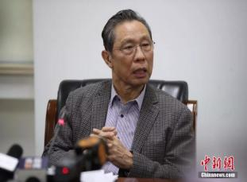

IMG_256

tell us how to protect ourselves (保护自己)



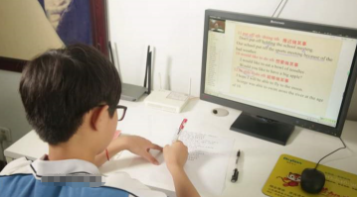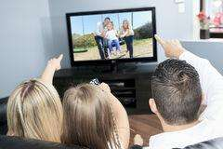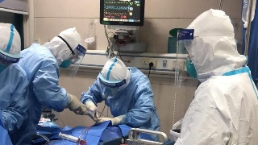

do research(研究)

try to save the patients(救治病人)

IMG_256

learn on the Internet

stay at home

*Now in China, we are fighting against the virus actively. ...*