**第一周第二课时《用英语讲故事》拓展资源**

**老鼠的故事The story of the Rat**

***2020 ---A year of the Rat***

2020 is a year of the Rat, starting from January 25th, 2020 and lasting until February 11th, 2021. It will be a Metal Rat year. In 2021,a year of the Ox will follow.

***Why is Rat the first?---Early Riser: Quick-Witted Rat***

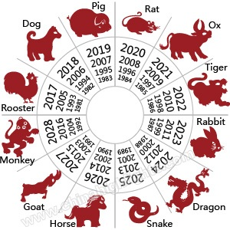The Year of the Rat is the first zodiac sign in the Chinese zodiac cycle. According to the Chinese zodiac story, the Jade Emperor holds a competition to decide the zodiac animals. Animals set off towards the Heavenly Gate. Rat gets up very early. On his way to the gate, he stops by a river. After waiting a long time, **Rat**sees Ox about to cross the river and swiftly **jumps into Ox's ear**. The diligent Ox does not mind at all and simply continues. After crossing the river, he races towards the palace of the Jade Emperor. Suddenly, **Rat jumps out of Ox's ear and rushes to** the feet of the Emperor. Rat wins the first place and Ox is the second.

The 12 zodiac animals are, in order: Rat, Ox, Tiger, Rabbit, Dragon, Snake, Horse, Goat, Monkey, Rooster, Dog, and Pig. A Rat year occurs every 12 years.

***The Rat’s Characteristics and Personality* 老鼠的性格特点**

Rats are quick-witted, resourceful, and smart but lack courage. With rich imaginations and sharp observations, they can take advantage of various opportunities well.

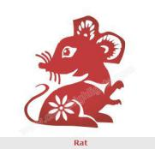In Chinese culture, rats represent working diligently and thriftiness, so people born in a Rat year are thought to be wealthy and prosperous.

***Rat Years***

Recent Rat years are 1948, 1960, 1972, 1984, 1996, 2008, and 2020.



**请同学们扫二维码，跟着视频学习鼠相的故事吧！**

***Word bank：***

zodiac sign：属相 diligent：adj. 勤奋的

quick-witted：adj.机智的 observations：观察力

resourceful adj.资源丰富的，机智的thriftiness：n.勤俭

Lack v.缺乏 various adj.各种各样的

Jade Emperor 玉帝 represent v.代表