**第一周第一课时《在语境下用词汇—家庭生活》拓展资源**

**Part I Read and learn**

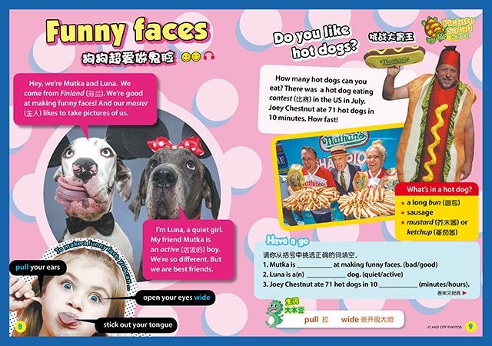

**Part II Word Puzzle**

**请你在下面的Word Puzzle里看看能找到多少个词汇? 哪些词汇是表达家庭成员的？**

|  |  |  |  |  |  |  |  |  |  |  |  |  |
| --- | --- | --- | --- | --- | --- | --- | --- | --- | --- | --- | --- | --- |
| d | a | u | g | h | t | e | r | r | m | s | f |  |
|  | t | h | e | s | e | h | s | i | s | t | e | r |  |
|  | i | u | n | c | l | e | l | g | p | h | o | t | o |
| p | a | r | e | n | t | s | y | h | h | e | l | e |  |
| c | o | u | s | i | n | e | x | t | g | y | u | i |  |